5 Most Rewarding Indoor Plants for Stress Relief and Fresh Air at Home
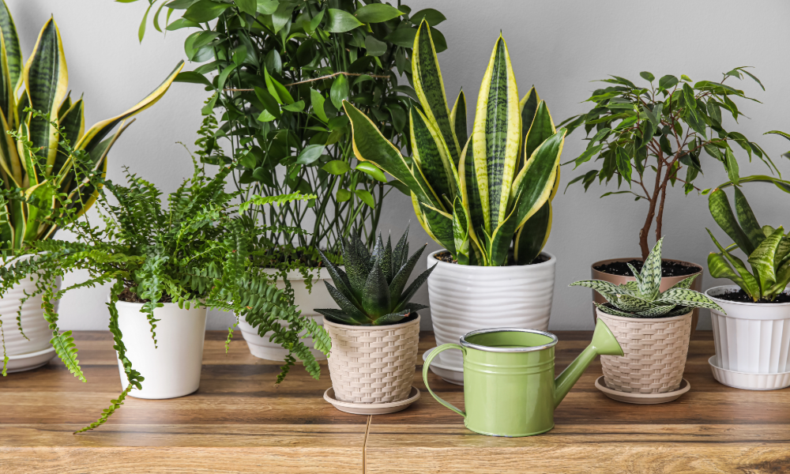
More people are turning their homes into green corners today. It is not just for greenery but for wellness. Indoor plants have a quiet yet powerful influence on our minds. They clean the air we breathe and all the spaces we live in. You may be working from home or studying late hours. You might simply need your room to feel more alive. The right plants in your vicinity can change the entire mood of your home. Below are the 5 rewarding plants that purify the air and reduce stress.

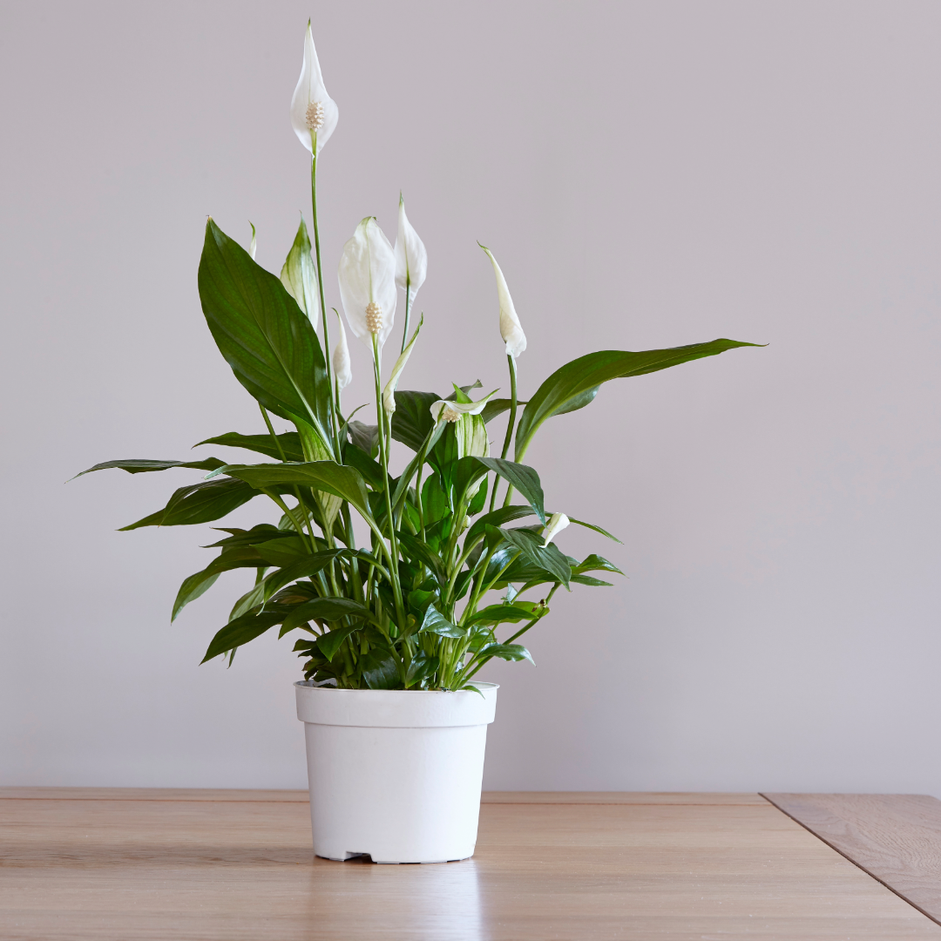

Peace Lily- The Calmness Creator
The peace lily is called a wellness plant. It is for a good reason. Its white blooms and deep green foliage instantly add a sense of serenity to any room. Peace lilies are excellent at absorbing toxins. It makes them perfect for bedrooms or workspaces. They grow well in medium light and just need watering once the soil dries halfway. A well-placed peace lily can make a room feel peaceful and breathable in just a few weeks.
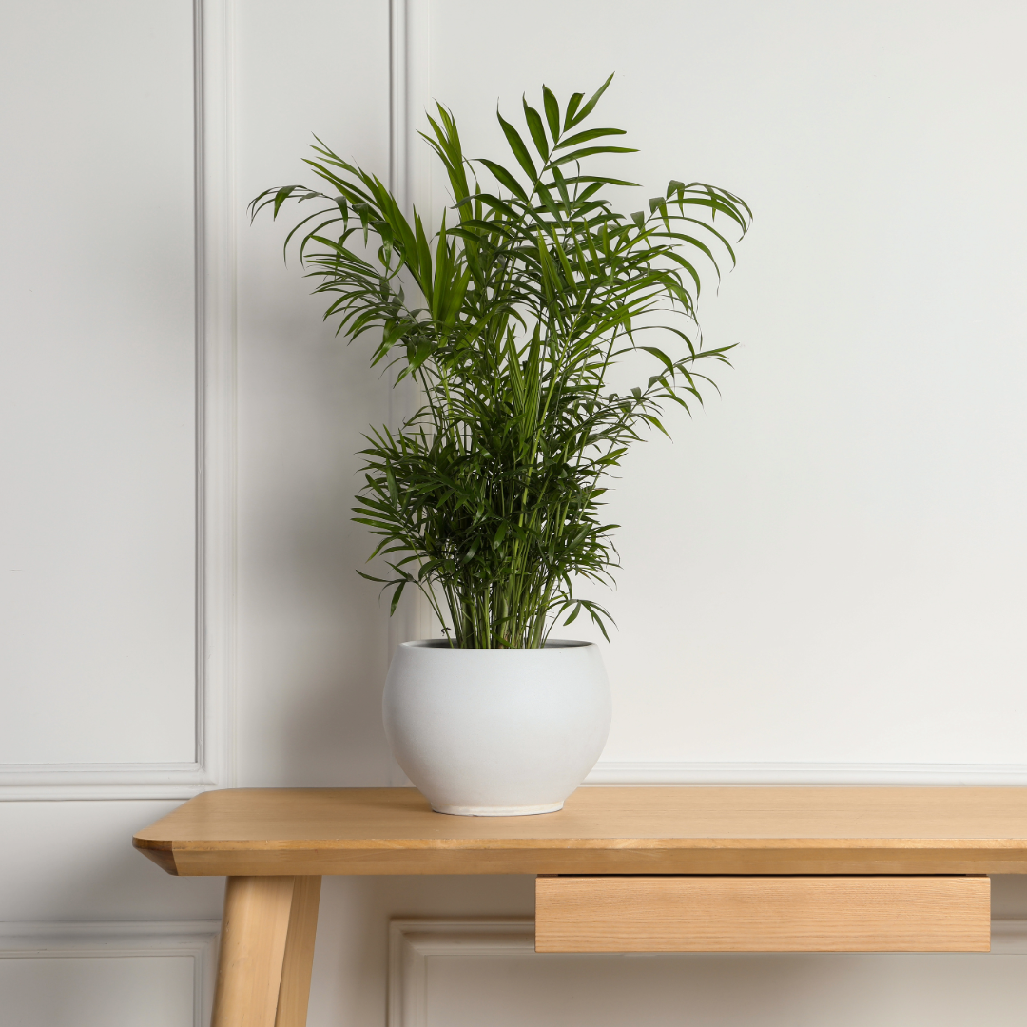

Areca Palm- The Natural Humidifier
The Areca palm acts like a natural humidifier. It releases moisture while improving oxygen levels. This plant is a blessing if you have dry skin or find your AC room dehydrating. It produces lush and arching fronds that soften corners that giving your room a tropical vibe. Keep it in bright and filtered sunlight. Water only when the topsoil feels dry. Steady care helps this plant grow gassy and fills your room with a refreshing jungle-like presence.
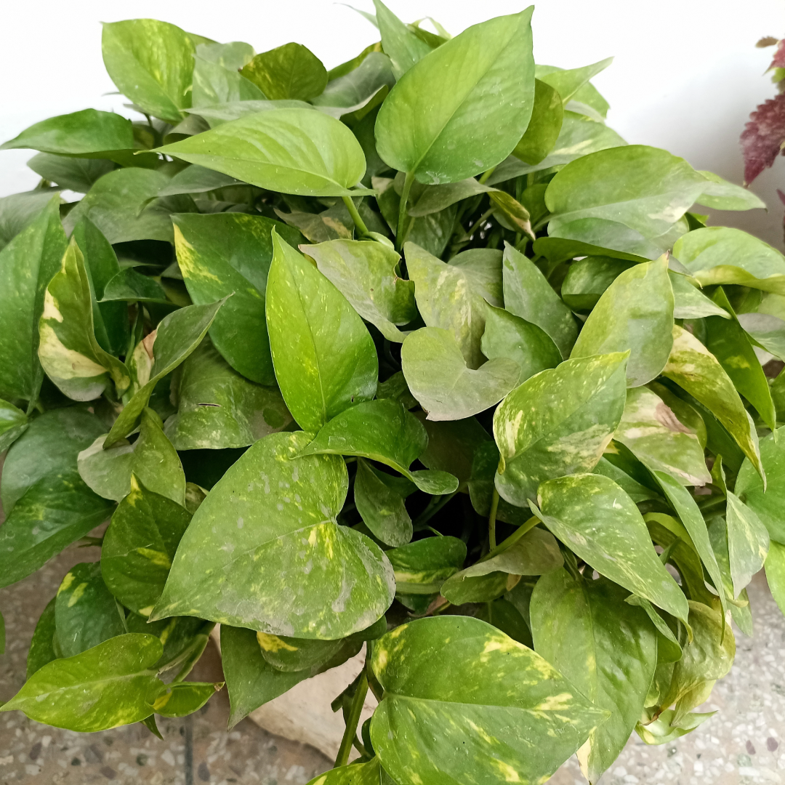

Money Plant- Easy and Qualifying Land, Always Growing
The money plant is ideal for beginners and is also believed to attract positivity as well as prosperity. It grows quickly. It trails beautifully and survives eleven days if you forget to water it for days. You can keep it in water jars or a hanging basket, or let it climb around your window. Money plant is known to remove indoor pollutants and improve airflow. This is why people keep their study desks and workstations neat. This plant never disappoints. It is flexible and cheerful.
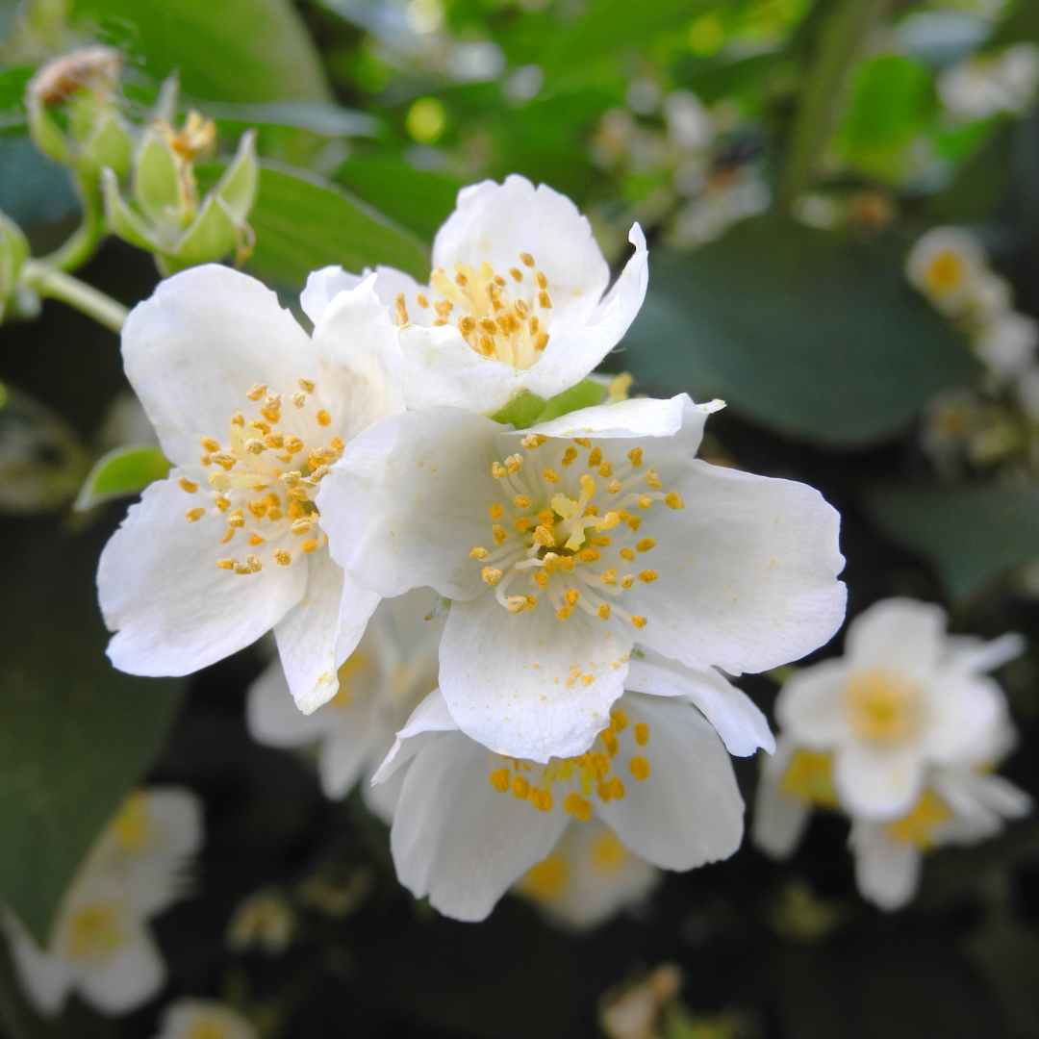

Jasmine- For Fragrance and Relaxation, as well as Peaceful Sleep
Jasmine is unmatched if you want a plant that soothes the senses instantly. Its fragrant flowers help reduce anxiety and improve sleep. It also helps in calming an active mind. Place it near a window where it can get sunlight and gentle airflow. Jasmine blooms regularly when pruned lightly and watered evenly. During the evening, the soft, sweet scent makes your room feel warm and romantic as well as grounding. It becomes perfect after a stressful day.
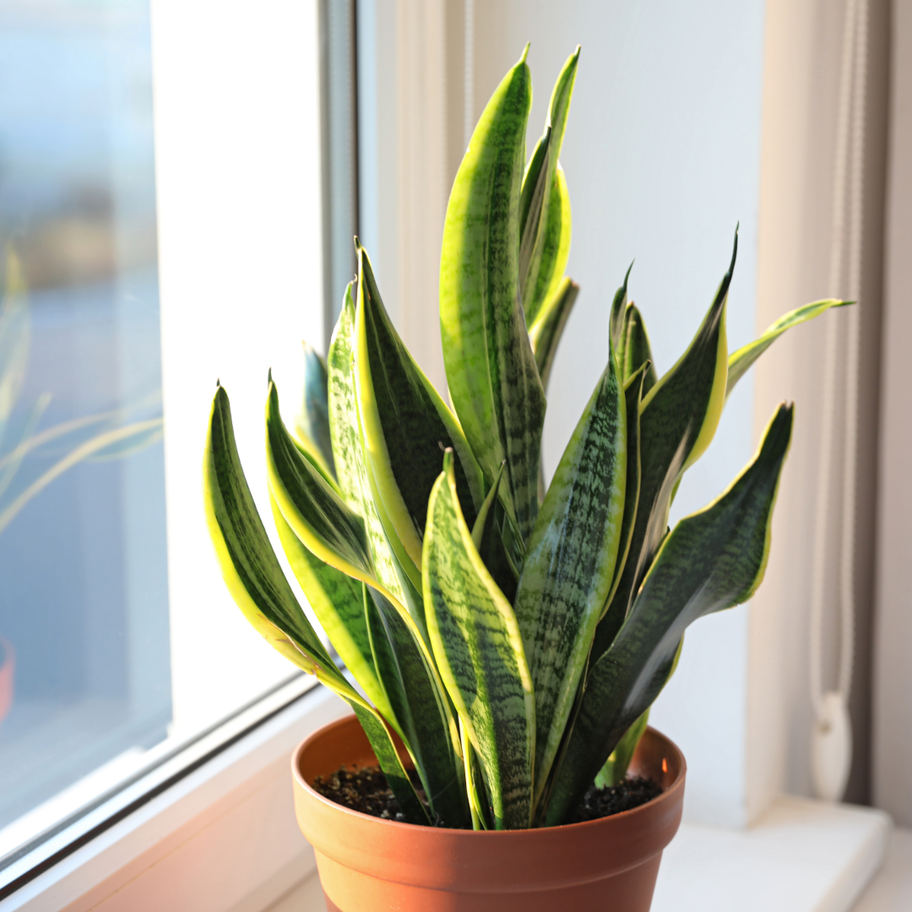

Snake Plant- The Overnight Oxygen Booster
The snake plant is finally called the plant that works while you sleep. It is unlike most plants that rest at night. Snake plants continue to release oxygen. It makes it ideal for bedrooms. It survives low light and irregular watering. It can even survive complete neglect. It is a true hero for busy plant parents; its sharp leaves add a modern edge to the interior decor while silently improving lung comfort. If you want a plant that supports your sleep and health, start with this one.

Final words
You do not need a large garden or extensive maintenance to feel the amazing power of the greenery of indoor plants. A small plant beside your window or a pot on your desk, or a fresh bloom near your bed is enough to shift your mood and refresh your breathing space. These give pants are easy to mainstream and give back much more than they ask for. Add just one of them today. And you will feel the difference in your home and in your mind.

FAQs
Which of these plants grows best for beginners?
Money plant and snake plant are the easiest and most low-maintenance options for new plant owners.
Can these plants survive in low light?
Yes. Snake plants and money plants do well in low light. Peace lily can also adapt to modern low light with modern watering.
How often should indoor plants be watered?
Most indoor plants need watering once the topsoil feels dry. Overwatering is more harmful than underwatering.
Which plant is best for improving sleep?
Snake plant and jasmine are great for bedrooms as they support relaxation and nighttime oxygen release.
Where should these plants be placed?
Near windows or on shelves, study tables or bedroom corners. Basically, anywhere with light, airflow and space for healthy growth is the right place for the plants to be placed.

